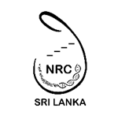
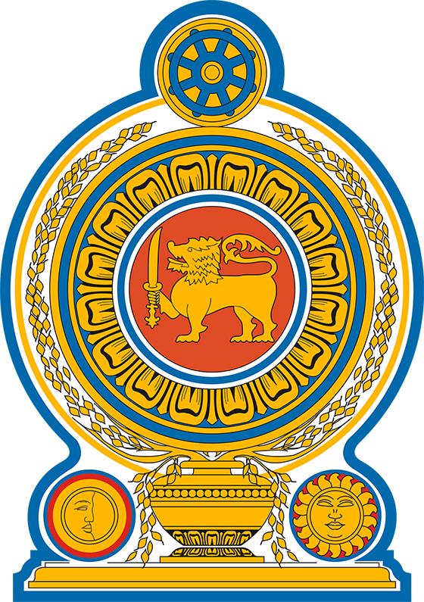
Ministry of Science & Technology
NATIONAL RESEARCH COUNCIL

PUBLIC-PRIVATE PARTNERSHIP GRANTS
CALL FOR PROPOSALS 2026

The National Research Council invites applications for projects up to LKR 6 million from private-sector organizations. The projects are funded on a 50:50 cost-sharing basis, where NRC contributes 50% (LKR 3 million), and the private sector organization contributes 50% of the total cost of the project. Up to 4 projects will be funded for the year 2026.

Public-private partnership (PPP) scheme uses a dual-stage process requiring the stage 1 submission (Expression of Interest – EoI) to be accepted before being invited to submit a detailed stage 2 proposal.

The projects should be innovative, grounded in strong evidence, and clearly demonstrate the potential to boost the national economy. Priority will be given to applications that focus on innovation and national interests, aimed at economic recovery and social resilience.

- Agriculture, Fisheries, Livestock, and Food Security
- Arts, Humanities, and Social Sciences
- Defence, International Relations and Economic Cooperation
- Education
- Energy, Engineering, Information, and other Technologies
- Health
- Natural Resources and Environmental Science
- Science and Technology
- Others (Law, Business & Management, Sport Science, Media, Pets Science, Sustainability Research, etc.)

For the year 2026, the call for proposals is issued in a single advertisement, but applicants may submit proposals by March 06, 2026, or June 01, 2026. The same application should not be submitted twice. Such applications will be rejected. Grants will be awarded depending on the availability of funds. The NRC’s decision will be final.
How to Apply:
Step 1: Download the EoI application form from the NRC website: www.nrc.gov.lk
Step 2: Read the guidance provided to complete the application
Step 3: Submit the proposal to NRC following the guidance notes provided. Use the following email: ppp@nrc.gov.lk (use only this email)
- One hard copy (original) should be sent by registered post, addressed to the Chairperson of the NRC, National Research Council, 120/7, Vidya Mawatha, Colombo 07.
- A PDF copy of the original application should be sent via email.
- The application should reach the NRC office by 4:00 pm on the designated deadline dates.

For further information, contact the NRC via email given below.

Tel: 011-2675176 Fax: 011-2675136 E-mail: ppp@nrc.gov.lk

Chairperson
National Research Council

